INTERACTIVE AML DASHBOARD
Using Microsoft Power BI
Project Report
Submitted By: Monica B
Course/Department: BCom Fintech and AI
Tool Used: Microsoft Power BI Desktop

1. Introduction
For this project, I developed an Interactive Anti-Money Laundering (AML) Dashboard using Microsoft Power BI. The dashboard uses transaction, account and alert-related data to analyse financial transactions and identify fraudulent activities.
The main purpose of this dashboard is to convert raw data into meaningful visual information. It helps users understand transaction patterns, monitor fraudulent transactions, analyse different alert types and review important financial information.
The dashboard includes KPI cards, line charts, donut charts, bar charts and slicers to make the analysis simple and interactive.

2. Objectives
The main objectives of this project are:
- To analyse transaction-related data using Power BI.
- To identify and monitor fraudulent transactions.
- To display important transaction details through KPI cards.
- To analyse transaction volume over time.
- To compare transactions based on fraud status.
- To analyse alerts based on different alert types.
- To create an interactive dashboard using slicers.
- To present complex financial information in a simple visual format.

3. Dataset Description
The dataset used in this project contains three main tables: Transactions, Accounts and Alerts.
The important fields used in the dashboard are:
1. Transactions
- TIMESTAMP – Records the date and time of transactions.
- IS_FRAUD – Indicates whether a transaction is identified as fraudulent.
- Transaction Amount – Represents the monetary value of transactions.
2. Accounts
- Contains account-related information used for account analysis.
3. Alerts
- ALERT_ID – Identifies individual alerts.
- ALERT_TYPE – Represents the category or type of alert generated.
These tables help analyse transaction activities, account information and alerts related to suspicious financial activities.

4. Data Preparation
Before creating the dashboard, the dataset was organised and prepared in Power BI Desktop.
The following activities were considered during data preparation:
- Imported the dataset into Power BI Desktop.
- Organised the data into Transactions, Accounts and Alerts tables.
- Used the TIMESTAMP field for time-based analysis.
- Used the IS_FRAUD field to identify fraudulent transactions.
- Used the ALERT_TYPE field to categorise alerts.
- Created DAX measures to calculate important values for the KPI cards and charts.

5. DAX Measures Used
DAX (Data Analysis Expressions) is a formula language used in Power BI to perform calculations and create measures.
The dashboard contains the following four important measures:
1. Total Transaction Amount
Displays the total monetary value of transactions recorded in the dataset.
2. Total Accounts
Displays the total number of accounts available in the dataset.
3. Total Transactions
Displays the total number of transactions recorded in the dataset.
4. Fraudulent Transactions
Displays the number of transactions identified as fraudulent.
These measures help users understand the overall transaction activity and monitor important fraud-related information.

6. Dashboard Components
The dashboard consists of the following visualisations.

KPI Cards
Four KPI cards are displayed at the top of the dashboard:
- Total Transaction Amount
- Total Accounts
- Total Transactions
- Fraudulent Transactions
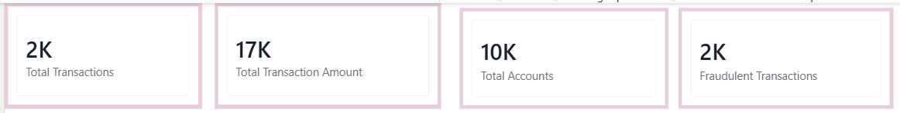
These cards provide a quick overview of the important information and help users understand the overall transaction performance.

Transaction Volume Across Timestamp
A line chart displays transaction volume across different timestamps. It helps users understand how transaction activities change over time and identify periods with higher or lower transaction volumes.
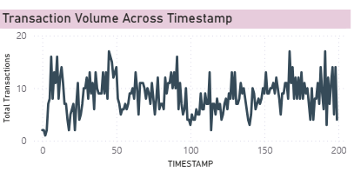

Transaction Distribution by Fraud Status
A donut chart represents the distribution of transactions based on their fraud status. It helps users understand the proportion of transactions classified under different fraud categories.
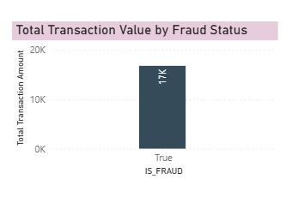

Fraudulent Transaction Volume Across Timestamp
A line chart displays fraudulent transaction volume over time. It helps users observe changes in fraudulent activities and identify periods where suspicious transactions are recorded.
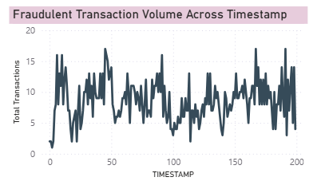

Alerts by Alert Type
A bar chart displays the number of alerts under different alert types. It helps users compare alert categories and identify which types of alerts are generated more frequently.

Total Transaction Value by Fraud Status
A column chart compares the total transaction value based on fraud status. It helps users understand the monetary value associated with the different fraud-status categories
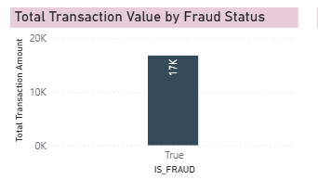.

7. Slicers Used
Slicers are used to make the dashboard interactive. The dashboard contains two slicers:
1. Fraud Status
This slicer allows users to filter the dashboard based on fraud status. It helps users focus on selected transaction categories.
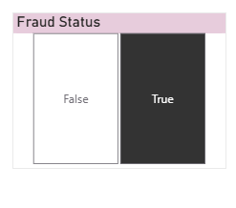
2. Alert Type
This slicer allows users to select different alert categories and analyse the corresponding alert information.
These slicers help users explore the dashboard according to their requirements.
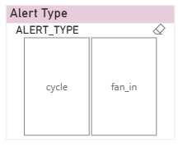

8. Key Findings
The dashboard provides the following important areas of analysis:
- The KPI cards provide an overview of total transaction amount, total accounts, total transactions and fraudulent transactions.
- The transaction volume chart helps identify changes in transaction activity over time.
- The fraudulent transaction volume chart helps monitor suspicious transaction patterns.
- The donut chart provides a visual representation of transaction distribution by fraud status.
- The alerts chart helps identify the different categories of alerts and their frequency.
- The transaction value chart helps compare monetary values across fraud-status categories.
- The slicers allow users to analyse selected fraud statuses and alert types.
Overall, the dashboard helps users understand transaction patterns and monitor fraud-related activities.

9. Conclusion
Developing this Interactive AML Dashboard using Microsoft Power BI helped me understand how raw financial data can be converted into meaningful visual information.
The dashboard combines different visualisations to analyse transactions, accounts, fraudulent activities and alerts. KPI cards provide a quick summary, while charts help identify patterns and compare different categories.
The use of slicers makes the dashboard interactive and allows users to explore the information based on their requirements.
Overall, this project improved my understanding of Power BI, data visualisation and the importance of data analysis in monitoring suspicious financial activities.

